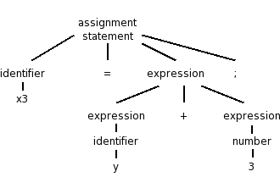Context free Grammar Definition: 1. There is a finite set of symbols that form the strings of the language being defined. These are known as terminals. 2. There is a finite set of variables also called sometimes non-terminals or syntactic categories. Each variable represents a language.3.One of the variables represents the language being defined, it is called the start symbol. Other variables represent auxiliary classes of strings that are used to help define the language of the start symbol. 4.there is a finite set of productions or rules that represent the recursive definition of a language. Each rule consists of (a) A variable that is being defined by the production. This variable is often called the head. (b) the production symbol 🡪. (c) A string of zero or more terminals and variables. This String is known as the body.

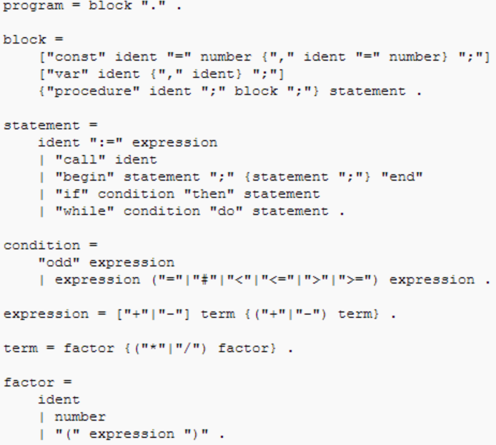Leftmost derivation basically just transform the non-terminals leftmost first so if A 🡪 a and B 🡪 b then for example S 🡪 AB => S🡪aB => S🡪ab. Right most would be S🡪AB => S🡪Ab => S🡪ab.

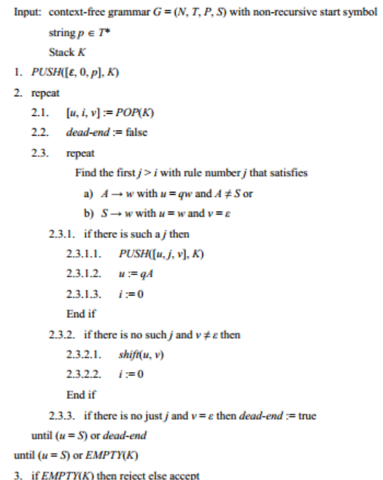Depth First Bottom Up Breadth First Bottom Up

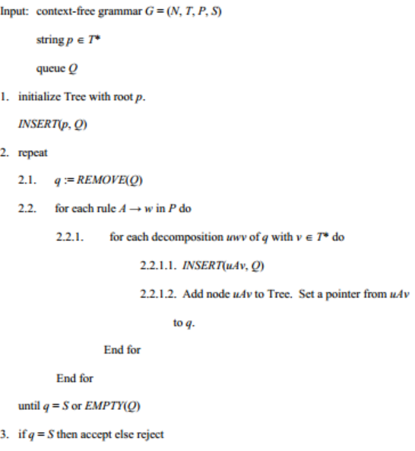

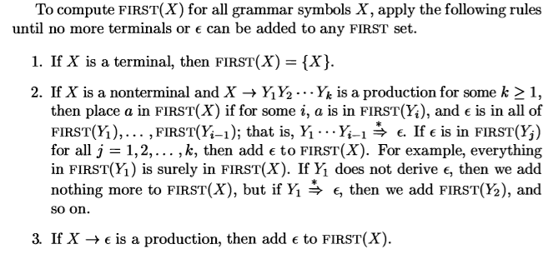

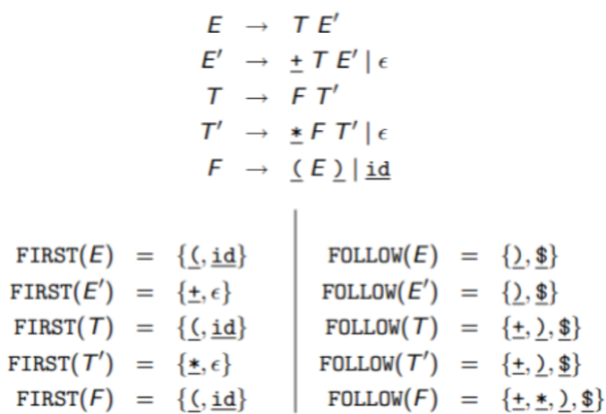

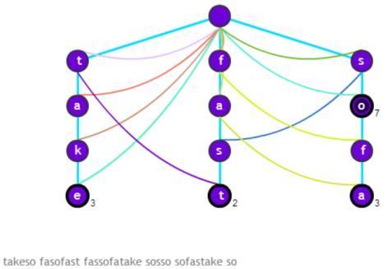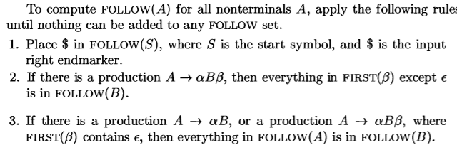Aho-Corasick Algorithm

